**FIVETRAN LOG CONNECTOR**

The Fivetran Log Connector delivers your logs and account metadata to a schema in your destination. This metadata includes granular Fivetran consumption information.

**1 .Setup Guide**

**1.1 Click on Add connectors**

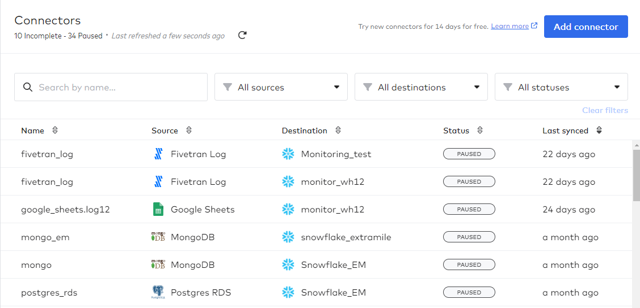

**1.2 Select your destination**

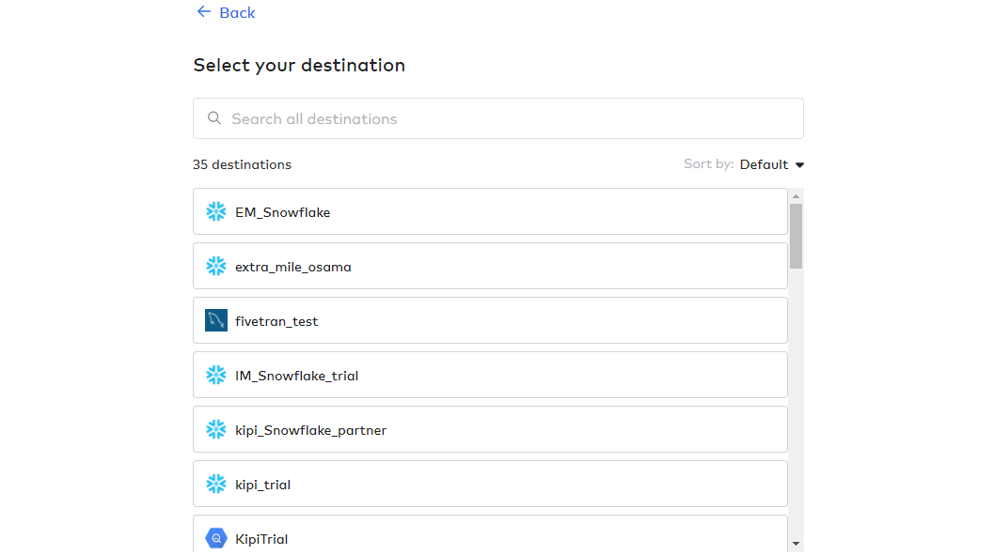

**1.3 Search for fivetran log and click on setup**

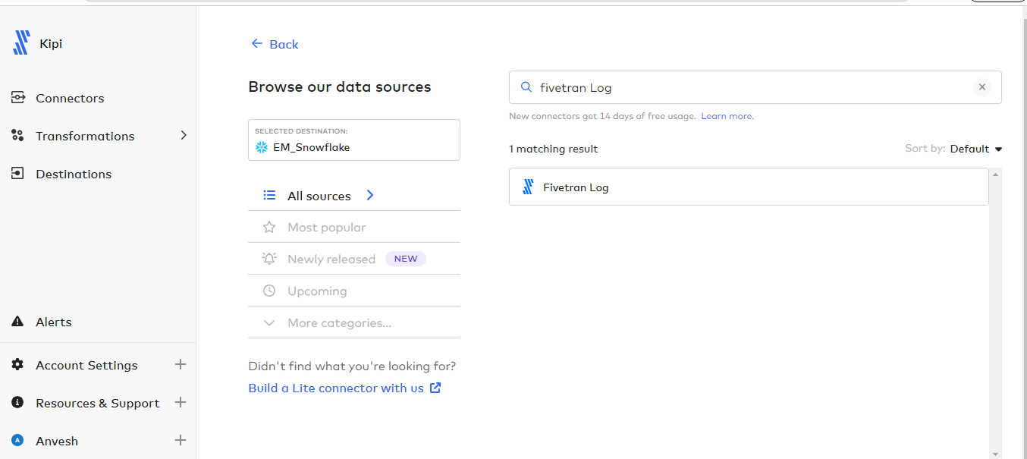

**1.4 click on save & Test**

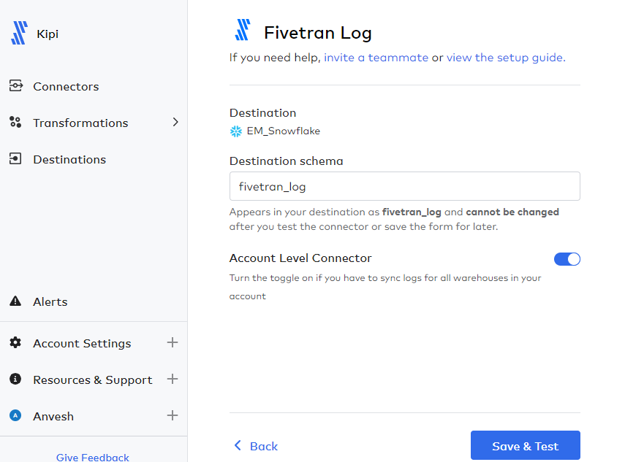

**1.5 Connection successful with all test passed**

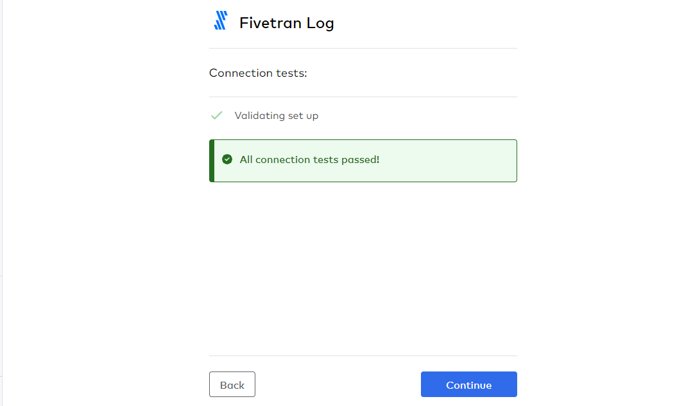

**1.6 click on start initial sync and after initial sync your logs stored in destination schema**

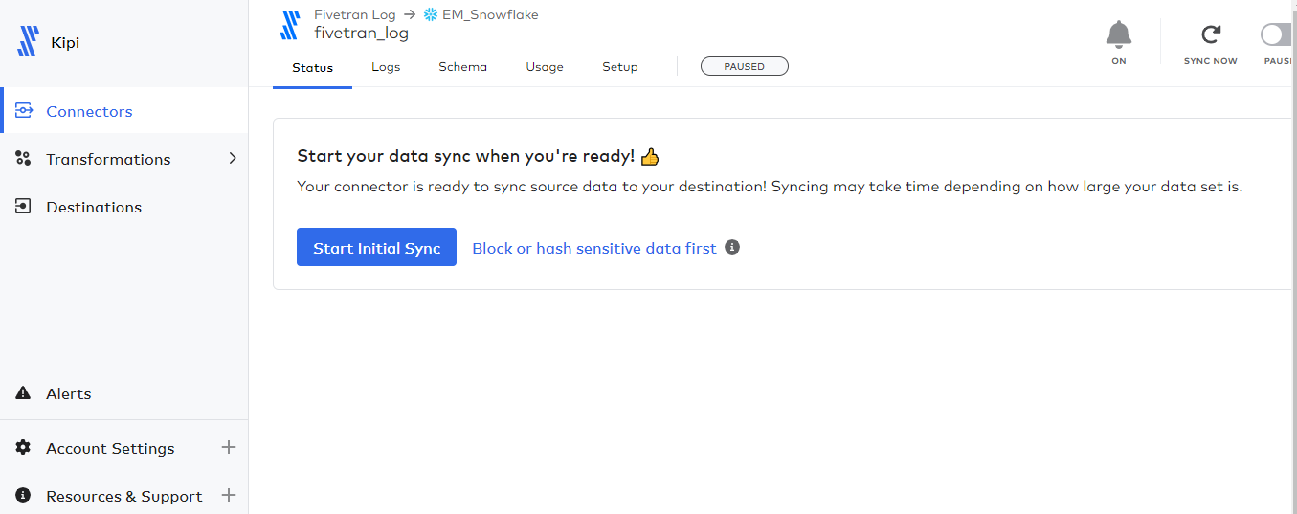

**1.7 Data at snowflake**

